A000-Cook-Engravings -2

Case No.: Oceania Engravings

**Kava ceremony - Poulaho King of Tonga - Cook / Webber 1785**

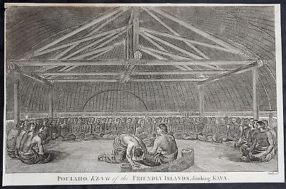

**A woman of Eaoo - Tonga - Cook / Webber 1785**

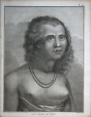

**Girl of Tahiti - French Polynesia - Cook / Webber 1785**

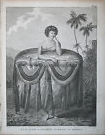

**Human sacrifice - Tahiti - French Polynesia - Cook / Webber 1785**

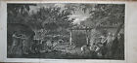

**View of Huahine - Society Islands - French Polynesia - Cook / Webber 1785**



[Opossum - Tasmania - Cook / Webber 1785](http://www.ebay.com/itm/311537821559?_trksid=p2057872.m2749.l2649&ssPageName=STRK%3AMEBIDX%3AIT)

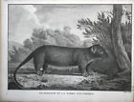

**Kalanimoku Hawaii - D'Urville 1841**

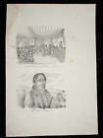

**Kalanimoku - Hawaii - Dumont D'Urville 1841**

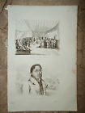

**Nāhienaena - Hawaii- Dumont D'Urville 1841**

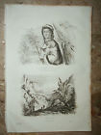

**The Death of Captain Cook - Hawaii - Cook / Webber 1785**

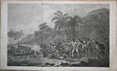

**Heiau - Hawaii - Cook / Webber 1785**

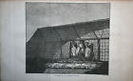

**Kauai - Hawaii - Cook / Webber 1785**

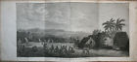

**Kealakekua Bay - Hawaii - Cook / Webber 1785**

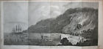

**Pirogue and masked warriors - Hawaii - Cook / Webber 1785**

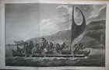

**Masked warrior - Hawaii - Cook / Webber 1785**

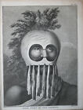

**Dancer of Hawaii - Tattoo - Cook / Webber 1785**

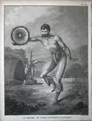

**Girl of Hawaii - Cook / Webber 1785**

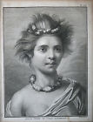

**Man of Hawaii - Cook / Webber 1785**

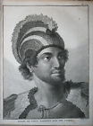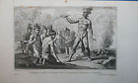

**Cook Islands - Tahiti - Dumont D'Urville 1841**

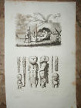

**House of a tribal chief in Hawaii - Domeny de Rienzi 1836**

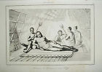

**Kauai - Hawaii - Cook / Webber 1785**

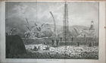

**King of Hawaii - Owyhee - Pirogue - Hawaii - Cook / Webber 1785**

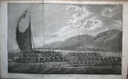

**Cook at Hawaii - Cook / Webber 1785**

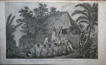

**Cook / Map of the Hawaiian islands-Webber 1785**

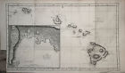

**Cook- RAIATEA Scene Double Canoe by Sydney Parkinson**-1787

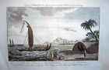

**Baldwyn 1794 A View near the Town of Pelew. Pacific**

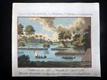

**1790s - GRASSET - MARQUISES**

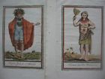

**1786 John Webber HAWAII Portraits Chief Kana'ina, Young Hawaiian Woman**

